CASE 7 BestChip: Expansion Strategy

BestChip (BC) is a large nationwide corporation that produces low-fat snack products for an expanding market (pun intended). Basically, BC takes materials (corn, wheat, and potatoes) and turns them into two types of snacks: chips (regular and green onion) and party mix (one variety). BC is expanding into the western United States and is considering sites for locating production facilities.

X1 = corn

X2 = Wheat

X3 = Potato

Y1 = Regular Chips

Y2 = Green onion chips

Y3 = Party Mix

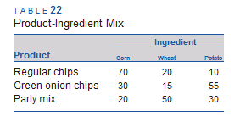

BC currently has eight candidate sites. Table 20 shows the sites ‘purchase prices and the purchase and shipping cost per ton of each material to each site.

The purchase cost represents the yearly amortized cost of opening and operating the site (exclusive of uses of the models.

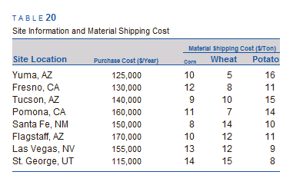

Each site may produce as many as 20,000 tons of product per year.

BC has six major customers, and all demand is shipped by truck from the plant to the customer warehouse. The shipping cost depends on the tonnage and distance and comes to $0.15 per ton-mile. The customers, their location, and their yearly demand in tons for each product are listed in Table 21. You must meet demand.

The makeup of the products does not depend on the production plant. Table 2 gives the productingredient mix data. The company requires that we consolidate our business, so we cannot locate plants in more than two states.

For this analysis, ignore the differences in property and income tax rates between the states (this is usually critical, but it gets us far afield of the key issue of math programming). In addition, many critical factors actually determine locations; for example, the method of financing the site purchase will also be a major factor in the decision—but we will ignore that also.

Your job is to determine how we should expand into the west and develop alternatives. Questions you should answer include:

What sites should be selected? How should the customers be served?

If gasoline gets more expensive and our trucking costs change, then how is the recommendation affected?

If rail freight costs for material shipping increase, then how is the recommendation affected?

Please consider other sensitivity-analysis issues that you feel might be important for management’s decision-making process.

TABLE 20 Site Information and Material Shipping Cost

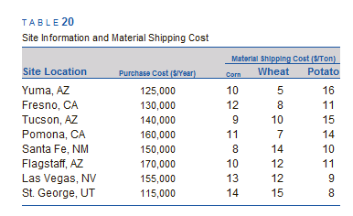

TABLE 21 Demand Information

Demand Company Location Regular Green Onion Party Mix

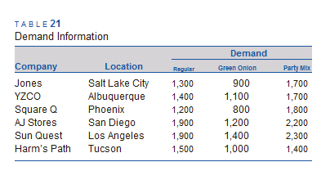

TABLE 2 Product-Ingredient Mix

